MV. ZHE HAI 515 – M/s. Chedid Re – Coils, Concrete Sheets and Gypsum Board
Our reference: 250915 – 1v2
Applicant/Reinsurance broker reference: Chedid Re
Ref no: 10/FAC/24/00673/25/00534
Contract/Policy ID: 427603 & 427604
Assured: STE. AFRI Food SARLU and /or their subsidiary and / or associated and/or affiliated companies (including Ste/ International Business Alliance sarl SARLU)
Agent/Broker: Elite Insurance
Ref No.: 122/2025
09 July 2026

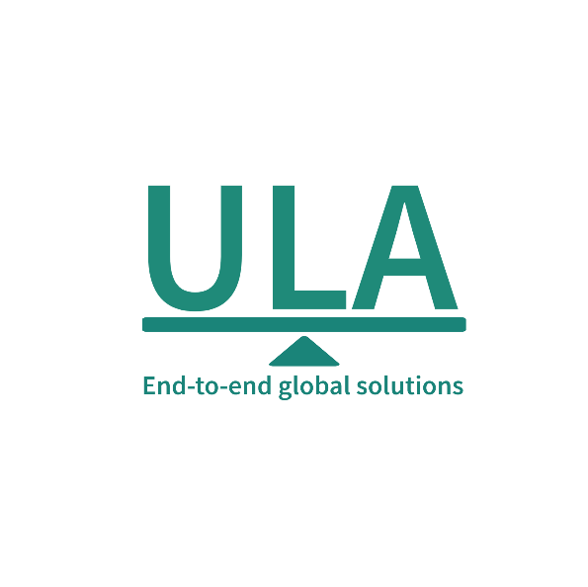
It’s about time you receive the quality of service and expertise your firm deserves.
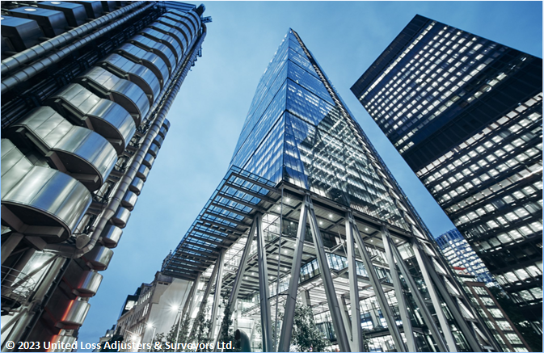

Document Control Page
Attended by: | Prepared by: | Reviewed & approved by:
Cai Dongliang  Robert Nsimba  Remy Kasangu  Jonathan Kanku | Annie Abdel Massih | Petro Zaarour
Designation: | Designation: | Designation:
Marine Surveyor to ULA in China  Marine Surveyor to ULA in Matadi  Marine Surveyor to ULA in Matadi  Marine Surveyor to ULA in Kinkole | Claims Director | UKI Chartered Engineer, Loss & Average Adjuster
Signature (Approver)
This survey and its issued report were completed without prejudice to all rights of parties.
Dates of visits
19 till 24 September 2025 at Tianjin Port, China
17 November till 9 December 2025 at Matadi Port
23 January 2026 at Kinkole – Consignee’s premises
Date of approval
09 July 2026

Version History | Date of issue | Reason for Revision
1 | 18 February 2026 | Issued – Preliminary – Pending receipt of additional info (see Appendix)
2 | 07 April 2026 | Issued - Final
3 | 09 July 2026 | Issued – Final – Following receipt of salvage sale invoices

The contents of this report are for the confidential information of the client.
This survey and its issued report were completed without prejudice to all rights of parties concerned.

Report Summary
At the request of the reinsurance brokers, Chedid Re, ULA was instructed to investigate a marine cargo claim concerning Coils, Concrete Sheets and Gypsum Boards for M/s. International Business Alliance SARLU (Ste Afri Food – the Assured), shipped onboard MV ZHE HAI 515 from Tianjin Port China to the port of Matadi, Congo. This investigation required the attendance of ULA’s surveyors on multiple occasions, commencing from 20 to 24 September 2025 at Tianjin Port, China; continuing from 17 November to 9 December 2025 at Matadi Port, onboard the subject vessel during discharge operations; and extending through to final delivery at the Consignee’s warehouse in Kinkole on 23 January 2026. Table 2 summarizes the salient details of the claim, and its representative photographs are included in Appendix B.
Table 1 - Claim summary and salient details
Reinsurance broker | Chedid Re – Ref no. 10/FAC/24/00673/25/00534
Agent/Broker | Elite Insurance Ref no. 122/2025
Initial claim on the policy | Claim reserve initially thought to be around USD 100,000 – Lowered to Circa USD 30,000.00 (before detailed segregation)
Consignee / Assured / Buyer | M/s. International Business Alliance SARLU &/or STE AFRI Food or any subsidiary name listed in the insurance policy
Terms of sale | FOB TIANJIN (no year of Incoterms version specified)
Policy basis of cover and details | - Policies Contract ID no.: 427603 & 427604  - Insured Value / BoV: Invoice Value + Freight + 10% as per Elite  - BoV on Policy: Invoice Value + 10%  - Period of Risk: From 03 November 2024 to 02 November 2025 (discharge completion date at Matadi, DRC on 17 November till 9 December 2025)  - Limit per shipment: USD 14,000,000 for breakbulk/bulk shipments  - Deductible: Shortage on bulk and/or break-bulk shipments: 0.5% of the Insured Value  - Insured value (Invoice Value + Freight +10% BoV): Calculated as USD 6,661,213.64 + USD 1,090,994.40 + 10% = USD 8,527,428.84 (below the limit)
- The Assured’s business involves importing galvanized coils, PPGI coils, HRS, concrete sheets, gypsum boards, IPE and angles for manufacturing in the DRC, and they are confirmed as an actual steel goods manufacturer and supplier.
- A fire occurred on 17 September 2025 in Hold No. 4 at Tianjin loading port while the vessel was berthed, with no General Average declared. Shipowners stated that only CO₂ was used for firefighting; however, silver nitrate testing confirmed seawater contamination on part of the steel cargo. To date, General Average was not declared by the carrier.
- Initial inspections in Tianjin (19–24 September 2025) revealed burnt gypsum boards, heat-affected steel, soot contamination, and seawater-induced rust, while bottom-stowed cargo could not be fully inspected.
- The vessel departed Tianjin on 25 September 2025, with further inspection deferred to the discharge port due to limited access and lack of fire investigation reports.
- The vessel arrived in Matadi on 17 November 2025, and discharge operations were conducted until 9 December 2025 under ULA surveyor attendance. During discharge, cargo was found with fire, heat, smoke, soot, seawater corrosion, and compromised packaging, and 35 packages of gypsum boards were completely burnt and left onboard for disposal.
- A final survey was conducted on 23 January 2026 at the consignee’s warehouse in Kinkole, DRC, after inland transport from Matadi. The shipment comprised 13 FOB Bills of Lading covering various steel products carried onboard MV ZHE HAI as part of a larger charterparty.
- Pre-loading reports from Bureau Veritas indicated cargo was in sound condition at Tianjin prior to shipment, pending receipt of detailed P&I cargo condition reports.
- The principal cause of the damage was the fire at Tianjin, which resulted from lashing work involving the welding of a D-ring in Cargo Hold No. 4. Sparks ignited materials in the hold, causing damage from heat, smoke, soot, and firefighting contamination, which was further aggravated by rough handling during discharge operations.
In our opinion:
- Having received salvage sale invoices, the final adjusted claim/policy indemnity falls under the deductible value.
- The carrier and their stevedore should be liable for damage to the cargo at the port of loading and discharge, for failure to care for it while in their custody, during unloading.
- A commentary on Insurable interest, policy coverage advice, and warranties/conditions compliance is included in Appendix A for Insurers' review.
Contents
1. Introduction 5
2. Nature of business 8
3. Sequence of surveys undertaken – 19 September 2025 till 23 January 2026 8
4. Claim overview, packing, and stowing review 9
5. Shipment details, bills of lading commentary and adjusters’ notes 9
6. Extent of loss and damage 13
7. Cause of loss/damage 14
8. Appointment of Assessors 15
9. Adequacy of Insured Value 15
10. Salvage Sale Invoice 15
11. Claim & Adjustment 16
12. Recovery & Merits 18
13. Conclusions 18
Appendix A - Commentary on Insurable interest, policy coverage advice, and warranties/conditions compliance (See attachments) 21
Appendix B - Representative photographs during the different surveys (additional available on request) – Additional photographs are included in the statements of facts (enclosed) 23

Introduction
At the request of the reinsurance brokers, Chedid Re, ULA was instructed to investigate a marine cargo claim concerning Coils, Concrete Sheets and Gypsum Boards for M/s. International Business Alliance SARLU (Ste Afri Food – the Assured), shipped onboard MV ZHE HAI 515 from Tianjin Port China to the port of Matadi, Congo.
This investigation required the attendance of ULA’s surveyors on multiple occasions, commencing from 20 to 24 September 2025 at Tianjin Port, China; continuing from 17 November to 9 December 2025 at Matadi Port, onboard the subject vessel during discharge operations; and extending through to final delivery at the Consignee’s warehouse in Kinkole on 23 January 2026.
The purpose of these attendances was to investigate the subject claim and validate it on the subject policy when presented. Table 2 summarizes the salient details of the claim and its representative photographs are included in Appendix B.
Table 2 - Claim summary and salient details
Reinsurance broker | Chedid Re – Ref no. 10/FAC/24/00673/25/00534
Agent/Broker | Elite Insurance Ref no. 122/2025
Initial claim on the policy | Claim reserve initially thought to be around USD 100,000 – Lowered to Circa USD 30,000.00 (before detailed segregation)
Various Shippers / Sellers & Cargo description | - M/s. Camino International Trade Company Limited – 202 Coils  - M/s. Qingdao JKL Co. LTD – 223 packages Gypsum Board  - M/s. Sino Steels (H.K.) Limited – 1,205 packages UPN / ANGLE / Flat Bars & Rolled Sheets  - M/s. Interior Global Co. Limited – 348 packages Coils & Tubes  - M/s. Realteam Industrial Limited – 85 packages Concrete Sheets, IPE & Streaked / Hot Rolled Sheets  - M/s. Hong Kong Topway Trading Co. LTD – 478 Coils  - M/s. Shenzhen Moyuxuan Import and Export Co, LTD – 136 Coils  - M/s. Steel Express (H.K) Limited – 233 Coils; 43 Bundles Hot Rolled Steel Sheets
Consignee / Assured / Buyer | M/s. International Business Alliance SARLU &/or STE AFRI Food or any subsidiary name listed in the insurance policy
Terms of sale | FOB TIANJIN (no year of Incoterms version specified)
Date of damage occurrence/discovery & Cargo Ownership | - Occurrence/Discovery: Fire occurred on 17 September 2025 inside Hold No. 4 while the vessel was berthed at Quay 10 at Tianjin Port, China (loading port)  - Sale Contract: Not made available to date; however, verbally confirmed by the Agent (Elite Insurance) that the cargo was owned by the Assured by custom of trade (FOB sale) at the time of loss/damage
Ports of loading/ discharge | Tianjin & Lianyungang, China / Matadi Port, DRC
Stevedore | M/s. Onatra at the port of Matadi (Carried out unloading operations)
Vessel Charterer’s Representative | M/s. AF Consultants represented by Mr. Theo & Mr. Marchetti
P&I Representative | M/s. Wiggins – Mr. Papy Mayemba - P&I: Skuld (IGPI Member)
Vessel key details | MV ZHE HAI 515 (Bulk carrier - IMO: 9679062) – Voy. No 25S52;  - Call Sign: BSEH; Flag: China; P&I: Skuld (IGPI Member);  - Classification society: CHINA CLASSIFICATION SOCIETY (IACS Member);  - Build year: 2013; (13 years old – Class A);  - Owners: ZHEJIANG SHIPPING GROUP CO.LTD  - Despondent Owners as per Fixture note: M/s. Topsheen
Bills of lading no. | - No. ZH25S52XGGMTD055 – 202 Coils  - No. ZH25S52XGGMTD001– 223 packages Gypsum Board  - No. ZH25S52XGGMTD021 – 480 packages UPN, Angle, Flat Bars, CRS & HRS  - No. ZH25S52XGGMTD028 – 422 packages CRS, HRS & Naval Sheets  - No. ZH25S52XGGMTD013 – 348 Coils, Tubes & Beams  - No. ZH25S52XGGMTD040 - 85 packages Concrete Sheets, IPE & Streaked / HRS  - No. ZH25S52XGGMTD002 – 478 Coils  - No. ZH25S52XGGMTD050 – 136 Coils  - No. ZH25S52XGGMTD005 – 63 Coils  - No. ZH25S52XGGMTD018 – 238 packages Tubes, IPE & Angle  - No. ZH25S52XGGMTD020 – 65 packages HRS & Angle  - No. ZH25S52XGGMTD007 – 43 Bundles HR Steel Sheets  - No. ZH25S52XGGMTD008 – 170 Coils  - Loaded relevant cargo holds: 2 & 4 (bottom tiers)  - Telex BLs Signed: by M/s. Sino Glory Logistics (Tianjin) Co. LTD as agent for and on behalf of the Master of MV ZHE HAI 515 dated 16 September 2025.  - Clausing: As detailed in paragraph‎5.
Fixture Note - Enclosed | The insured cargo was part of a wider voyage charter, which included other cargo onboard.  Note: The Charterparty agreement was not supplied only the Fixture note was made available.
Cargo Ownership | Sale Contract: Not made available to date; however, verbally confirmed by the Agent (Elite Insurance) that the cargo was owned by the Assured and evidenced by proof of payment (transfer copies enclosed)
Policy basis of cover and details | - Policies Contract ID no.: 427603 & 427604  - Insured Value / BoV: Invoice Value + Freight + 10% as per Elite  - BoV on Policy: Invoice Value + 10%  - Period of Risk: From 03 November 2024 to 02 November 2025 (discharge completion date at Matadi, DRC on 17 November till 9 December 2025)  - Limit per shipment: USD 14,000,000 for breakbulk/bulk shipments  - Deductible: Shortage on bulk and/or break-bulk shipments: 0.5% of the Insured Value  - Invoices:  - No. CMJXF250903: USD 516.610.38  - No. JKLIBA250619C: USD 94,128.30  - No. IVSS2566A: USD 1,016,471.17  - No. IVSS2566B: USD 1,703,804.37  - No. TT250691: USD 440,365.96  - No. SRT20251077: USD 213,050.76  - No. F008-251033: USD 468,446.58  - No. F008-251018: USD 643,629.22  - No. F008-250955: USD 268,046.28  - No. IVSS2567: USD 211,680.22  - No. IVSS2568: USD 156,121.25  - No. F008-250954: USD 102,443.80  - No. F008-251047: USD 826,415.65  - Insured value (Invoice Value + Freight +10% BoV): Calculated as USD 6,661,213.64 + USD 1,090,994.40 + 10% = USD 8,527,428.84 (below the limit per shipment)
Policy Law & Jurisdiction | This Insurance shall be governed by and construed in accordance with the Law of England and Wales, and each Party agrees to submit exclusive Jurisdiction to the Courts of England and Wales
Risk Duration | Bulk and/or Breakbulk Shipments are on a “Seaport to Seaport” basis, and cover ceases once the Goods have been unloaded from the Carrying Seagoing Vessel with No Risk after Discharge (NRAD) – including loading and unloading
Claim relevant shipment basis of Cover, conditions and warranties | - Institute Cargo Clauses “A” CL. 382 dated 01.01.2009  - Including Loading and Unloading Operations if and as Original Institute Marine Policy General Provisions (Cargo) CL. 269 dated 01.10.1982  - Institute Replacement Clause CL. 372 dated 01.12.2008  - Debris Removal Clause; Sue and Labor Clause  - Fumigation Expenses  - Sorting Charges & Repacking Costs  - Goods Purchases on FOB, C&F, or similar Terms Clause  - Excluding Mysterious and/or Unexplained disappearance  - Excluding Unexplained Shortage, Infidelity, Fraud and Dishonesty  - Excluding Rust, oxidation, Corrosion and Discoloration unless caused by an insured peril under ICC “B”  - Excluding Twisting, Chipping, Denting, Spotting, Bending, Marring, Staining and Distortion unless caused by an insured peril under ICC “B”  - Warranted Independent Satisfactory Pre-Shipment Loading, Stowage, Moisture Survey along with Loading and Discharge Bags Tally Survey at the Original Assured’s Expense, applicable to Bulk and/or Break-Bulk Shipments  - Warranted that Quantity and Quality of Cargo loaded shall be Certified /Supervised by Qualified Third Party Independent Marine Surveyors with All Survey Fees at the Original Assured’s Expense.  - Warranted Third Party Independent Surveyors of International Repute to supervise the Loading Operations with All Survey Fees at the Original Assured’s Expense, applicable to Bulk and/or Break-Bulk Shipments  - Warranted Vessels entered into a reputable P&I Group / Club / Association /  - Warranted Vessels must be IACS Classed with Class maintained at all times during sailing  - Warranted Shipped under a clean Original Bill of Lading and/or Original Air Waybill and/or Original Packing List and/or Original Commercial Invoice and/or Original Shipping Manifest (discussed in paragraph 5)
Date of vessel departure /arrival | 25 September 2025 vessel departed port of loading Tiyanjin, China  17 November 2025 vessel arrived at the final destination port of Matadi, DRC
Date of final discharge | 09 December 2025 (Matadi - DRC)
ULA instruction date | 17 September 2025 (ULA was tasked on the day the fire erupted on board the subject vessel while berthed at loading port – Tianjin, China)
Surveys details | - 19 till 24 September 2025 at Tianjin Port, China – onboard the vessel  - 17 November till 9 December 2025 at Matadi Port (onboard the vessel and at port)  - 23 January 2026 at Kinkole – Consignee’s/Assured premises
Joint surveys attending parties | - Present during joint Surveys:  On board the vessel at Tianjin Port:  - Cai Dongliang – for Cargo Insurers (ULA)  - Thomas – Assured / Consignee’s representative  On board the vessel at Matadi Port:  - Robert Nsimba – for Cargo Insurers (ULA)  - Remy Kasangu – for Cargo Insurers (ULA)  - Vessel Chief Officer  - M/s. Onatra Stevedoring (Carried out unloading operations)  - M/s. AF Consultants represented by Mr. Theo & Mr. Marchetti – Vessel Charterer Representative  - M/s. Wiggins Mr. Papy Mayemba – P&I (SKULD) Representatives  At the Consignee’s/Assured warehouse in Kinkole:  - Mr. Aymen Ben Haj – Consignee’s representative  - Mr. Jonathan Kanku - for Cargo Insurers (ULA)  - Mr. Deo Mwema Malaba – Representing Wiggins on behalf of owner’s P&I

Nature of business
On the basis of the surveys and investigations undertaken by the attending Surveyors to ULA, we were able to confirm that the nature of the Assured’s business includes the import of Galvanized Coil, PPGI Coil, HRS, Concrete Sheets, Gypsum Board, IPE & Angle for the production at their factory in DRC, which is consistent with their declared activity.
The Assured was also confirmed as the actual manufacturer and supplier of steel goods, enabling easier means of minimising losses.

Sequence of surveys undertaken – 19 September 2025 till 23 January 2026
- As declared by the carrier, a fire occurred on 17 September 2025 inside Hold No. 4 of the subject vessel, while berthed at Quay 10, Tianjin Port, China (loading port). ULA’s representative Surveyor in China attended from 19 to 24 September 2025. He initially met with the vessel’s charterers’ P&I Surveyor and the Chief Officer, during which it was confirmed that General Average was not declared.
Shipowners confirmed that no water was injected into Hold No. 4 and that only CO₂ was used; however, silver nitrate testing conducted by ULA’s surveyor on the steel cargo yielded positive results, indicating contact with seawater.
As of 21 September 2025, the Fire Department and the MSA had concluded their investigations, and the relevant reports have been requested however not made available. As most of the cargo was loaded at the bottom of the hold and covered with steel plates and other cargo, the full extent of the damage was not visible; however, the visible cargo showed that the outer packaging of some pieces of gypsum board was burned, the steel cargo on the ground surface was affected by seawater and tested positive for silver nitrate, and the cargo surface was contaminated with soot, with the overall extent of damage to be determined at the final destination.
- The vessel arrived at the final destination port of Matadi on 17 November 2025. Discharge operations for the subject cargo commenced on the same date and were completed on 9 December 2025 in the presence of ULA’s correspondent surveyor. During the discharge process, portions of the cargo were found to have sustained fire damage and rusting caused by seawater used during fire-extinguishing operations at the loading port, with their packaging visibly compromised. A full and detailed assessment of the damage was deferred until the cargo could be unwrapped at the consignee’s premises.
It is further noted that 35 packages, STC 134 pieces of gypsum (Gyproc) each, were completely burnt by fire and remained onboard the vessel for disposal by the vessel interests, as the consignee was unwilling to incur additional destruction or disposal costs at their own expense. A Letter of Protest (LOP) was duly issued to the ship and stevedores at the time (copy enclosed).
ULA maintained a constant presence during the entire unloading process and issued the enclosed initial Statement of Facts (SOF) covering preliminary observations of the damaged cargo and the need for subsequent inspection. All attending parties signed the SOF.
- Subsequently, a final survey was conducted on 23 January 2026 at the Assured/Consignee’s warehouse in Kinkole, DRC. Following the final inspection, a Final Statement of Facts (SOF) (copy enclosed) was issued at the final delivery warehouse. Unpacking at the port was deemed neither feasible nor practical. The Assured and their Agent subsequently provided final supporting documents and information in January 2026, submitted in support of their claim validation.

Claim overview, packing, and stowing review
During our attendance onboard the vessel, we were able to confirm that part of the cargo had sustained fire-related damages, corrosion (rust staining), mechanical damage, and packaging deterioration.
It is noted that the Shipped Bills of Lading (copies enclosed) were claused, recording that the cargo loaded was in a fire-damaged condition and/or with defects, including rust staining, chafing and scratching, nicked or bent edges, torn or wrinkled wrappings (in some cases with inner contents exposed), broken or missing strapping bands, damaged edge protection fittings, oil/grease staining, dirt contamination, and in certain instances storage in open air without cover prior to shipment.
Excluding the fire and firefighting-related damage, the aforementioned pre-shipment conditions are consistent with weather exposure, handling issues, and packaging deficiencies noted after the fire damage had occurred. These conditions may explain part of the apparent deterioration noted at discharge and may have marginally influenced the perceived condition of the cargo; however, they are not considered to be the primary cause of the more substantial damage observed upon outturn.

Shipment details, bills of lading commentary and adjusters’ notes
- The Assured / Consignee had arranged for the insured shipment under 13 Bills of Lading (FOB) from China to Matadi onboard MV ZHE HAI. This was part of a wider Charterparty where cargoes for several interests were also delivered to several ports in Africa.
- The Assured had bought the insured cargo from eight different sellers/shippers. Notably, 2 sets of Bills of Lading were presented by the Assured during different stages of the claim. The first set was issued Clean on Board and the second set “Shipped BLs” were all claused following the fire incident.
- After the vessel experienced the fire incident, the ship’s Mate, supported by their P&I Club loading surveyor, claused the ‘Shipped Bills of Lading’. Based on these, the revised Bills of Lading were issued to the Assured.
A commentary on compliance with the policy material warranty on ‘Clean onboard BLs’, is included in Appendix A.
- The new ‘Shipped Bills of Lading’ included the following clauses confirming this:
- No. ZH25S52XGGMTD055 – 202 Galvanized Steel Coils: Cargo condition as per attached P&I cargo condition report as a part of this mate's receipt; Quantity &weight as per tally and shipper's declaration; Quality unknown; shipped on deck /hatch cover at charterers / shippers /receiver's entire risk expense and responsibility, without liability on the vessel or her owners for any loss damage expenses or delay howsoever caused; Outer circumferential wrappings locally scratched/indented.; Core wrapping locally indented/buckled, affect 17 coils; Strapping bands partly/locally rust stained; Strapping bands broken/missing I piece, affect 3 coils; End edge protection ring locally bent/indented, affect 25 coils; Suffered varying degrees of fire damages during loading, e.g. burnt, heat damage, smoke & soot damage, water or contamination damage from firefighting agents; Outer circumferential wrapping locally indented/buckled, affect 13 coils; Strapping bands partly rust stained; End disc locally indented/buckled, affect 13 coils.
- No. ZH25S52XGGMTD001 – 223 Packages Gypsum Board: Cargo condition as per attached P&I cargo condition report as a part of this mate's receipt; Quantity & weight as per tally and shipper's declaration; Quality unknown; Outer packaging bags locally dirty; Suffered varying degrees of fire damages during loading, e.g., burnt, heat damage, smoke & soot damage, water or contamination damage from firefighting agents.
- No. ZH25S52XGGMTD021 – 480 packages UPN / ANGLE, Flat Bar & IPE, CRS & HRS: Partly rust stained. Edge/flange locally indented/nicked 2-4 pieces; Bent at ends 1-2 pieces, affect 2 bundles; Strapping bands broken 1-2 pieces, affect 15 bundles; Suffered varying degrees of fire damages during loading, e.g., burnt. heat damage, smoke & soot damage, water or contamination damage from firefighting agents; Locally stained oil/grease, affect 5 bundles; Flat bars stored in open air without cover; Locally stained with oil/grease; Stored in open air without cover; Locally rust stained. Bars/Oats locally nicked/indented 2-5 pieces; Locally rust stained for hot rolled sheets; Locally chafed for hot rolled sheets; Wrappings of cold rolled sheet detached and repaired, affected 1 package; Upper wrappings locally indented/buckled. Lower wrappings locally tom with inner contents exposed. Wrappings locally indented/buckled/lacerated; Wrappings Locally rust stained; Cargo condition as per attached P&I, Cargo condition report as a part of this mate's receipt. Quantity/weight as per tally and shipper’s declaration; Quality unknown.
- No. ZH25S52XGGMTD028 – 422 packages CRS & HRS, Naval Sheet: Partly rusted stained; Locally nicked at edges 2-4 pieces. Stored in open air without cover. Locally bent/nicked al edges 2-4 pieces; Suffered varying degrees of fire damages during loading, e.g., burnt, heat damage, smoke & soot damage, water or contamination damage from firefighting agents. Locally rust stained. Outer circumferential wrapping locally torn with cargo exposed, affect all; Core wrapping locally torn with cargo exposed, affect 23 coils; Edge protecting ring locally bent/indented; Strapping bands broken5 piece, affect 11 coils. Outer circumferential wrapping locally indented/scratched, affect 3 coils. End disc locally tom, affect I coil; Number 2250805260/1-3; Edge protecting ring locally indented/chafed, affect 6 coils. Strapping bands broken/missing 1 piece, affect 2 coils. Locally chafed on surface or at edges 4 pcs.
- No. ZH25S52XGGMTD013 – 348 packages PPGL Coils / Black Rectangular Tubes / Black Round Tubes, IPE Beam: Wrappings locally chafed/scratched/indented; Strapping bands partly/locally rust stained; Strapping bands broken/missing I piece, affect 3 coils. End edge protection ring locally bent/indented, affect 8 coils; Dust stained; Suffered varying degrees of fire damages during loading. e.g., burnt, heat damage, smoke & soot damage, water or contamination damage from firefighting agents; Outer wrappings locally torn; Strapping bands broken/detached 1-2 pieces, affect 15 bundles; End wrappings locally wrinkled, affect 18 bundles; Stored in open air without cover; Rust stained; Edge/flange locally indented/nicked 2-4 pieces; Bent at ends 1-2 pieces, affect 3 bundles; Strapping bands broken 1-2 pieces, affect 2 bundles; Locally stained with oil/grease; Cargo condition as per attached P&I, Cargo condition report as a part of this mate's receipt; Quantity/weight as per tally and shipper's declaration; Quality unknown.
- No. ZH25S52XGGMTD040 – 85 packages Concrete / Streaked Sheets, IPE & HRS: Cargo condition as per affected P&I cargo condition report as a part; quality & weight as per tally and shipper's declaration; quality unknown; outer wrappings locally indented/buckled; outer wrappings locally torn with inner wrappings exposed, affected 2 bundles; strapping bands broken 1-2 pieces, affect 6 bundles; smoke damaged, stained with a layer of soot, affected all; suffered varying degrees of fire damages during loading. e.g., burnt, heat damage, smoke & soot damage, water or contamination damage from firefighting agents; partly/locally rust stained; edge/flange locally indented/nicked/dent 2-4 pieces; locally stained with oil/grease; stored in open air without cover; partly rust stained; locally bent/nicked at edges 2-4 pieces.
- No. ZH25S52XGGMTD002 – 478 Coils: Cargo condition as per attached P&I cargo condition report as a part of this mate's receipt; quantity & weight as per tally and shipper's declaration; quality unknown; wire rods locally chafed/scratched; windings twisted and/or tangled locally, affect 25 coils; dust stained.
- No. ZH25S52XGGMTD050 – 136 Coils: Wrapping sheets locally chafed/scratched/indented/wrinkled; End edge protection ring locally bent/indented, affect 14 coils; Circumferential/core wrappings torn with inner contents exposed, affect 2 coils; Number JP542212FOD2FOOOS & JP542229FOD2FOOOS; Stored in open air wi1hout cover; Wrappings locally tom with inner contents exposed; Edge protecting ring locally bent/indented; Strapping bands broken 1 piece, affect 8 coils.
- No. ZH25S52XGGMTD005 – 63 Coils: Cargo condition as per attached P&I cargo condition report as a part of this mate's receipt; quantity & weight as per tally and shipper's declaration; quality unknown; Wrapping locally chafed/scratched/indented; strapping bands partly/locally rust stained; strapping bands broken / missing 2 pieces, affect 8 coils; end edge protection ring locally bent / indented, affect 16 coils; core wrappings locally wrinkled and inner wrappings locally exposed, affect 1 coil (JP545443F0D2F); dust stained.
- No. ZH25S52XGGMTD018 – 238 Packages Rectangular Tube, IPE & ANGLE: Outer wrappings locally torn; Strapping bands broken/detached 1-2 pieces, affect 12 bundles; End wrappings locally wrinkled, affect 16 bundles; Partly rust stained; Edge/flange locally indented/nicked 2-4 pieces; Bent at ends 1-2 pieces, affect 3 bundles; Strapping bands broken 1-2 pieces, affect 8 bundles; Locally stained oil/grease, affect 7 bundles; Suffered varying degrees of fire damages during loading, e.g. burnt, heat damage, smoke & soot damage, water or contamination damage from firefighting agents; Cargo condition as per attached P&I, Cargo condition report as a part of this mate's receipt; Quantity /weight as per tally and shipper’s declaration; Quality unknown.
- No. ZH25S52XGGMTD020 – 65 Packages HRS & ANGLE: Strapping bands broken/missing 1-2 pieces, affect 4 bundles; Locally chafed/scratched on surface; Locally bent/indented/nicked at edges 1-2 pieces, affect 8 bundles; Dust stained; Suffered varying degrees of fire damages during loading, e.g., burnt, heat damage, smoke & soot damage, water or contamination damage from firefighting agents; Cargo condition as per attached P&I, Cargo condition report as a port of this mate's receipt; Quantity/weight as per tally and shipper's declaration; Quality unknown.
- No. ZH25S52XGGMTD007 – 43 Bundles HR Steel Sheets: Cargo condition as per attached P&I cargo condition report as a part of this mate's receipt; quantity & weight as per tally and shipper's declaration; quality unknown; Strapping bands broken/missing 1-2 pieces, affect 3 bundles; Locally chafed/scratched on surface; Locally bent/indented/nicked at edges 1-2 pieces, affect 7 bundles; Dust stained
- No. ZH25S52XGGMTD008 – 170 Coils HR Steel Coils: Cargo condition as per attached P&I cargo condition report as a part of this mate's receipt; quantity & weight as per tally and shipper's declaration; quality unknown; Locally chafed/scratched on surface; Strapping bands broken/missing 3-4 pieces, affect 4 coils; Locally bent/indented/nicked at the winding edges; core windings telescoped, affect 5 coils; Dust stained.
- Although the bills of lading were claused at the time of loading, they primarily / mostly referred to packaging issues, such as loosened strapping, damaged edge packing, and rust on the coil surfaces (Note: Rust is excluded either way in the policy), rather than the underlying condition of the steel coils themselves.
- The proximate cause of damage/loss of the cargo concerned in the subject claim is attributable to the fire incident which occurred at the Tianjin loading port, as a result of the associated heat, smoke, soot and firefighting seawater contamination, which was further aggravated by rough handling by the stevedores (M/s. Onatra) at the port of discharge. This is further evidenced by the Letter of Protest issued by the Consignees / Assured dated 22.11.2025 (copy enclosed).
- ULA was supplied with the requested pre-loading reports (copies enclosed):
- The reports issued by Bureau Veritas indicate that a survey was conducted, and the cargo was found to be in sound condition when inspected at Tianjin Port.
- According to the Mate’s Receipts (copies enclosed), a remark was noted on cargo condition as per the P&I cargo condition report.
- Pre shipment cargo condition report issued by Ms. Beacon Marine Consultant Co., Ltd and signed by Master of M/V “ZHE HAI 515” (copy enclosed) noted the following: strapping bands broken, outer package dirty, locally nicked / scored / bent, twisted, wrapping wrinkled / buckled, wrapping scratched, edge protection ring bent, rust stained, oil stained, polyester wrapping torn in places, stored in open air.

The pre-shipment condition report issued at the time of loading, primarily referred to packaging issues, such as broken strapping, damaged edge packing, and rust / oil on the coil surfaces, rather than the underlying condition of the steel coils themselves. The observations largely indicated external or superficial issues, with limited reference to structural damage affecting the integrity of the cargo.

- As outlined in paragraph 3 and based on the prescribed, ULA’s inspection onboard vessel at loading port conducted from 19 till 24 September December 2024, concluded the following:
- Joint inspections confirmed visible fire, heat, smoke, and seawater damage to part of the cargo stowed in Hold No. 4.
- Observed damages included burnt and heat-affected gypsum boards (with charred wooden supports), 12 steel plates and 6 bundles of H-beams showing heat exposure and seawater-induced rusting.
- Silver nitrate testing yielded positive results, confirming chloride contamination consistent with seawater contamination.
- Steel coils stowed at the bottom of the hold were not accessible and their condition remained unknown at the time of survey.
- Despite requests, the vessel did not discharge the affected hold for a comprehensive joint inspection, and no fire investigation documentation was provided during attendance.
- The vessel subsequently departed Tianjin on 25 September 2025, with further inspection to be conducted at the discharge port.
- It should be noted that efforts were made to get a fire investigator onboard; however, they were unable to board the vessel, given difficulties in gaining access to the country.

- ULA’s findings during discharge inspection – Matadi (17 November – 9 December 2025): During the attendance of ULA’s correspondent Surveyor throughout the discharge operations, the following findings were recorded:
- Portions of the cargo were found to have sustained fire-related damage, including heat effects and smoke/soot staining, consistent with the fire incident at the loading port of Tianjin.
- Evidence of seawater exposure was observed on part of the cargo, resulting in rusting and surface corrosion, attributable to firefighting operations carried out at origin.
- Various packages exhibited compromised packaging, including burnt, torn, or weakened wrappings and damaged securing bands.
- Several units showed rust staining and surface deterioration, some consistent with prolonged moisture exposure.
- Due to tight wrapping and bundled stowage, the full extent of internal damage could not be ascertained at the quay side, and a detailed assessment was therefore deferred pending unwrapping at the consignee’s premises.
- A total of 35 packages, STC 134 pieces of gypsum board (Gyproc) each, were found completely burnt and deemed beyond recovery. These remained onboard the vessel for disposal by vessel interests, as the Assured/Consignee declined to bear destruction/disposal costs at the discharge port.
- Over the period that followed on from the prescribed surveys, the cargo was subsequently transported from Matadi Port, DRC, onboard trucks to be delivered at the final destination warehouses located in Kinkole, DRC. Subsequently, a final survey was conducted on 23 January 2026 at the Assured/Consignee’s warehouse in Kinkole, DRC. Following the final inspection, the findings were reproduced in Table 3 below.

Extent of loss and damage
Table 3 outlines the extent of loss and damage, including the agreed depreciation of damaged items, as part of determining the measure of indemnity.
Table 3 – Extent of loss and damage, and depreciation applied
Commodity Description | Qty Pcs | Damaged (pcs) / Applied depreciation
 |  | 25% | 10% | 5% | Loss/Ton
COIL 914X0.14MM BG39 | 2 |  | 1 | 1 | 0.735
COIL 914X0.17MM BG34 | 2 |  |  | 2 | 0.366
IPE 80-6M | 11 |  | 11 |  | 0.032
ANGLES 100X100X8 MM | 1 |  |  | 1 | 0.003
ANGLES 100X63X6 MM | 2 |  |  | 2 | 0.004
HRS 2000X1000X1MM | 267 | 267 |  |  | 1.001
HRS 2000X1000X1.5MM | 555 |  | 555 |  | 1.332
CRBA 0.8*1250MM | 2 |  |  | 2 | 1.177
HRC-1250MM-1MM | 2 |  |  | 2 | 1.709
HRC-1250MM-1.2MM | 1 |  | 1 |  | 1.713
COIL PPGL RAL 9003 | 5 |  |  | 5 | 1.413
COIL PPGL RAL 5017 | 3 |  |  | 3 | 16.35
RECTANGULAR TUBE 100X50X1.5MM | 166 | 153 | 13 |  | 0.780
RECTANGULAR TUBE 100X50X2MM | 39 |  | 39 |  | 0.103
RECTANGULAR TUBE 60X40X1.2MM | 184 | 184 |  |  | 0.506
IPE 100-6MM | 13 |  | 13 |  | 0.053
IPE 120-6MM | 9 |  | 9 |  | 0.046
IPE 140-6MM | 7 |  | 7 |  | 0.043
CONCRETE SHEET -305-915X5800X0.8MM | 98 |  | 98 |  | 0.427
HRC-1250MM-2MM | 1 |  |  | 1 | 0.500
CRBA-1250MM-0.6MM | 2 |  |  | 2 | 0.788
HRC-1250MM-1MM | 16 |  | 1 | 15 | 7.056
HRC-1250MM-2MM | 1 |  |  | 1 | 0.508
GYPROC 2440X1200X9MM GREEN APPLE | 526 | 50 | 15 | 461 | 526 pcs
GYPROC 2440X1200X9 MM GREEN APPLE | 4702 | Loss 100% (Total loss) |  |  | 4702 pcs

Cause of loss/damage
The proximate causes of loss and/or damage pertaining to this claim, based on the investigations, are outlined below and detailed in Table 4 with respect to the timing of loss/damage.
- The fire incident that occurred at Tianjin loading port was reportedly caused by lashing work involving the welding of a D-ring in Cargo Hold No. 4, during which sparks fell into the hold and ignited combustible materials. The resulting damage was caused by heat, smoke, soot, and contamination by seawater from firefighting efforts (Noted on the Shipped bills of lading, as detailed in paragraph 5 [4]).
- Rough handling by the carrier and their stevedores during discharge operations (Ocean Cargo Insurers were on risk). According to the attending ULA Surveyor and the Consignee’s representatives, the cargo was handled roughly during discharge, as evidenced in the Initial Letter of Protest (LOP - Enclosed). Although the stevedores declined to sign the surveyor’s findings, the document was duly signed by the Master/Chief Officer of the vessel and the P&I representative Surveyor.
Subsequently, a second Letter of Protest (LOP) was issued by the Assured/Consignee reiterating the same concerns relating to the rough handling of the cargo. It is also noted that ULA representatives were present throughout the discharge operations.
Table 4 – Cause and timing of loss/damage
BL No. | Leg on Risk | Qty | Caused by
ZH25S52XGGMTD055 | During Loading / Unloading | 4 | Fire damage initially, further aggravated by rough handling by the carrier and their stevedores during discharge operations (Ocean cargo Insurers were on risk).
ZH25S52XGGMTD001 | During / After Loading | 5228 | Fire (Ocean cargo Insurers were on risk)
ZH25S52XGGMTD021 | During Loading / Unloading | 836 | Fire damage initially, further aggravated by rough handling by the carrier and their stevedores during discharge operations (Ocean cargo Insurers were on risk).
ZH25S52XGGMTD028 | During Loading / Unloading | 5 | Fire damage initially, further aggravated by rough handling by the carrier and their stevedores during discharge operations (Ocean cargo Insurers were on risk).
ZH25S52XGGMTD013 | During Loading / Unloading | 426 | Fire damage initially, further aggravated by rough handling by the carrier and their stevedores during discharge operations (Ocean cargo Insurers were on risk).
ZH25S52XGGMTD040 | During Loading / Unloading | 98 | Fire damage initially, further aggravated by rough handling by the carrier and their stevedores during discharge operations (Ocean cargo Insurers were on risk).
ZH25S52XGGMTD050 | During Unloading | 1 | Rough handling by the carrier and their stevedores during discharge operations (Ocean cargo Insurers were on risk).
ZH25S52XGGMTD005 | During Unloading | 2 | Rough handling by the carrier and their stevedores during discharge operations (Ocean cargo Insurers were on risk).
ZH25S52XGGMTD008 | During Unloading | 17 | Rough handling by the carrier and their stevedores during discharge operations (Ocean cargo Insurers were on risk).

Appointment of Assessors
To date, the Assured had not appointed a loss assessor or Surveyor to act on their behalf.

Adequacy of Insured Value
The insured value of the subject consignment (Invoice value + Freight + 10%) is USD 8,527,428.84, which is below the limit of the Insured Value per shipment, USD 14,000,000.00, indicating that coverage was appropriate. In addition, the cargo's sound market value was confirmed as appropriate. On the basis of documents provided to date, we were able to conclude that there is no evidence to suggest cargo underinsurance.

Salvage Sale Invoice
The Assured arranged for the sale of the salvageable cargo (previously claimed as partially damaged), as the condition of the goods rendered them unsuitable for their intended production purpose. The total proceeds from the salvage are enclosed summing up to USD 271,804.96.

Claim & Adjustment
Table 5 summarises the claim presented on the policy and adjusted policy indemnity; damages caused by rust/signs of corrosion are not listed below, as these were not claimed for by the Assured.
Table 5 – Claim & Adjustment
Commodity Description | Qty Pcs | Loss/Ton (NW) | Unit Price USD / MT | Policy Coverage | Invoice Value of affected cargo (USD) | Freight Added (as per Elite’s Schedule to Insurers (USD 80 / MT)
COIL 914X0.14MM BG39 | 2 | 9.80 | 660.00 | Clause 1 Of CL 382 – ICC A 1.1.09 | Add 6,468.00 | Add 784.00
COIL 914X0.17MM BG34 | 2 | 7.32 | 613.00 |  | Add 4,487.16 | Add 585.60
IPE 80-6M | 11 | 0.32 | 570.00 |  | Add 182.40 | Add 25.60
ANGLES 100X100X8 MM | 1 | 0.07 | 460.00 |  | Add 32.20 | Add 5.60
ANGLES 100X63X6 MM | 2 | 0.08 | 470.00 |  | Add 37.60 | Add 6.40
HRS 2000X1000X1MM | 267 | 4.10 | 528.00 |  | Add 2,164.80 | Add 328.00
HRS 2000X1000X1.5MM | 555 | 13.25 | 510.00 |  | Add 6,757.50 | Add 1,060.00
CRBA 0.8*1250MM | 2 | 23.54 | 529.00 |  | Add 12,452.66 | Add 1,883.20
HRC-1250MM-1MM | 2 | 34.18 | 515.00 |  | Add 17,602.70 | Add 2,734.40
HRC-1250MM-1.2MM | 1 | 17.30 | 512.00 |  | Add 8,857.60 | Add 1,384.00
COIL PPGL RAL 9003 | 5 | 28.30 | 642.00 |  | Add 18,168.60 | Add 2,264.00
COIL PPGL RAL 5017 | 3 | 16.35 | 642.00 |  | Add 10,496.70 | Add 1,308.00
RECTANGULAR TUBE 100X50X1.5MM | 166 | 1.6 | 532.00 |  | Add 883.12 | Add 132.80
RECTANGULAR TUBE 100X50X2MM | 39 | 0.78 | 525.00 |  | Add 409.50 | Add 62.40
RECTANGULAR TUBE 60X40X1.2MM | 184 | 1.84 | 560.00 |  | Add 1,030.40 | Add 147.20
IPE 100-6MM | 13 | 0.52 | 468.00 |  | Add 243.36 | Add 41.60
IPE 120-6MM | 9 | 0.45 | 468.00 |  | Add 210.60 | Add 36.00
IPE 140-6MM | 7 | 0.42 | 465.00 |  | Add 195.30 | Add 33.60
CONCRETE SHEET -305-915X5800X0.8MM | 98 | 2.94 | 592.00 |  | Add 1,740.48 | Add 235.20
HRC-1250MM-2MM | 1 | 10.00 | 484.00 |  | Add 4,840.00 | Add 800.00
CRBA-1250MM-0.6MM | 2 | 15.74 | 540.00 |  | Add 8,499.60 | Add 1,259.20
HRC-1250MM-1MM | 16 | 132.80 | 560.00 |  | Add 74,368.00 | Add 10,624.00
HRC-1250MM-2MM | 1 | 10.17 | 525.00 |  | Add 5,339.25 | Add 813.60
GYPROC 2440X1200X9MM GREEN APPLE | 5,228 | 97.92 | 3.15 (per piece) |  | Add 16,468.20 | Add 7,833.60
Totals | - | - | - |  | USD 201,935.73 | USD 34,388.00
Total Admissible Claim on Chedid Re policy (land transit damage excluded) --------------------------------------------------------------------------------------------------- USD 236,323.73
Uplift + 10% as per BOV ----------------------------------------------------------------------------------------------------------------------------------------------------------------------- USD 259,956.10
Less Salvage Sale USD 271,804.96 ------------------------------------------------------------------------------------------------------------------------------------ Minus USD 11,848.86
Less Applicable deductible - Shortage on Bulk and/or Break-Bulk Shipments: 0.5% of Insured Value (USD 8,527,428.84) ------------------------------------- Less USD 42,637.14
Adjusted Claim Amount Falls Under the deductible value -------------------------------------------------------------------------------------------------------------------- Minus USD 54,486.00

Recovery & Merits
The following parties are considered potential recovery targets, noting that the B/Ls are signed by Sino Glory Logistics (Tianjin) Limited as ‘agent for and on behalf of the master of MV ZHE HAI 515’. These are to be further scrutinised during the claim recovery process.
- The Carrier is considered a potential target.
- The Stevedore (Onatra) is also thought to be liable for rough handling during discharge operations.
Recovery merits against the carrier/charterers will likely be stronger than those against the stevedoring company, given the fire incident at the loading port. Given the adjusted quantum of loss, the pursuit of the claim recovery by cargo Insurers may be uneconomical.

Conclusions
In our opinion,
- Having received salvage sale invoices, the final adjusted claim/policy indemnity falls under the deductible value.
- The carrier and their stevedore should be liable for damage to the cargo at the port of loading and discharge, for failure to care for it while in their custody, during unloading.
- Commentary on Insurable interest, policy coverage advice, and warranties/conditions compliance is included in Appendix A for Insurers' review.
We confirm sighting the original relevant documents submitted to date, customarily made available in support of a claim of this nature.
End of report.

Claim supporting documents
Report Enclosed Documents:
- Appendix A - Commentary on Insurable interest, policy coverage advice, and warranties/conditions compliance
- Policy AXA XL
- Fixture Note
- Telex BLS
- Initial Bls Front & Reverse
- Commercial Invoices
- Packing Lists
- Certificates of Origin
- Stowage Plan
- Hatch No.4 detailed list
- Port of Call List
- Arrival Report
- LOP & Notice from Med Logistics
- Outbound cargo manifest
- Crew List
- LOP issued by Consignee
- Notice issued by Consignee
- Sub Hatch List
- Mates’ Receipts
- BIVAC Reports
- LOP issued by ULA
- Notice 2 issued by Consignee
- Damage note
- Shipping Orders
- Final SOF
- Vessel’s Details
- Freight Payments
- P&I cargo condition reports (mentioned in the Telex BLs and in the Mate’s Receipts)
- Proof of Payment
- Salvage Sale Invoices

Documents that remained unavailable as per the Assured and their Agent:
- Fire Rescue Administration and the Maritime Safety Administration (MSA) reports.
- Charterparty agreement

References
- Information received from the Assured and their Agent between September 2025 and February 2026, via email.

Appendix A - Commentary on Insurable interest, policy coverage advice, and warranties/conditions compliance (See attachments)
Risk Duration and Insurable Interest:
- Bulk and/or Breakbulk Shipments are on a “Seaport to Seaport” basis, and cover ceases once the Goods have been unloaded from the Carrying Seagoing Vessel with No Risk after Discharge (NRAD)
- Including all Loading and Unloading risks
- Goods Purchased on FOB Or Similar Terms Clause: It is hereby understood and agreed that the goods are at the Underwriters' risk and that their liability to the Assured commences from the time the goods leave the Suppliers' Factory or Warehouse, as if the Contract of Sale was "ex Suppliers' premises" notwithstanding that the goods and/or interest may have been purchased on "FOB", or similar terms. Underwriters being subrogated to the rights of recourse against the Suppliers.
At the time of loss, and on the basis of information available, including the terms of sale (FOB), we are of the view that the Assured had insurable interest at the time of damage/loss, which primarily occurred during cargo unloading at the port of discharge.
Warranties / Conditions / Exclusions commentary:
The following relevant Basis of Cover were examined as part of validating the subject claim:
- Institute Cargo Clauses “A” CL. 382 dated 01.01.2009
- Including Loading and Unloading Operations if and as Original Institute Marine Policy General Provisions (Cargo) CL. 269 dated 01.10.1982
- Excluding Mysterious and/or Unexplained disappearance
- Excluding Unexplained Shortage, Infidelity, Fraud and Dishonesty
- Excluding Rust, oxidation, Corrosion and Discoloration unless caused by an insured peril under ICC “B”
- Excluding Twisting, Chipping, Denting, Spotting, Bending, Marring, Staining and Distortion unless caused by an insured peril under ICC “B”
- Warranted Independent Satisfactory Pre-Shipment Loading, Stowage, Moisture Survey along with Loading and Discharge Bags Tally Survey at the Original Assured’s Expense, applicable to Bulk and/or Break-Bulk Shipments
- Warranted that Quantity and Quality of Cargo loaded shall be Certified /Supervised by Qualified Third Party Independent Marine Surveyors with All Survey Fees at the Original Assured’s Expense.
- Warranted Vessels entered into a reputable P&I Group / Club / Association / Warranted Vessels must be IACS Classed with Class maintained at all times during sailing
- Deductible Shortage on bulk and/or break-bulk shipments: 0.5% of Insured Value
- Policy Law & Jurisdiction: This Insurance shall be Governed by and construed in accordance with the Law of England and Wales, and each Party agrees to submit exclusive Jurisdiction to the Courts of England and Wales.
As the loss/damage spanned from fire and rough handling, we are of the view that the claim relevant, warranties and conditions, had been complied with, and should not bar the Assured from recovering on the policy.
The following warranty merited further examination:
Warranted Shipped under a clean Original Bill of Lading and/or Original Air Waybill and/or Original Packing List and/or Original Commercial Invoice and/or Original Shipping Manifest
ULA Commentary: From investigations completed by ULA, we were able to confirm that the Assured was not privy to the claused bills of lading prior to the fire occurrence. The prescribed facts in our opinion (other than fire-related damage), are not material to the claim, as packaging damage was not claimed for, and significant damage was confirmed to have occurred due to the fire at the loading port and the rough handling at the discharge port.
Policy coverage advice:
In our opinion, damage to the cargo should be recoverable under Clause 1 of CL 382, as a fortuitous loss and damage, which occurred while Insurers were on risk and the Assured had an insurable interest.

Appendix B - Representative photographs during the different surveys (additional available on request) – Additional photographs are included in the statements of facts (enclosed)
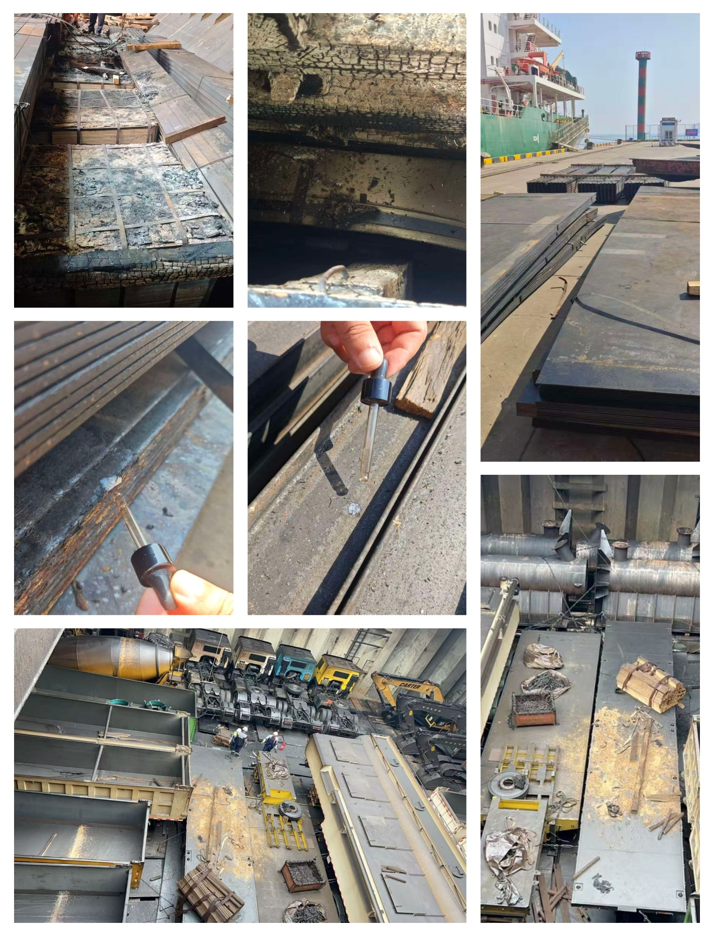
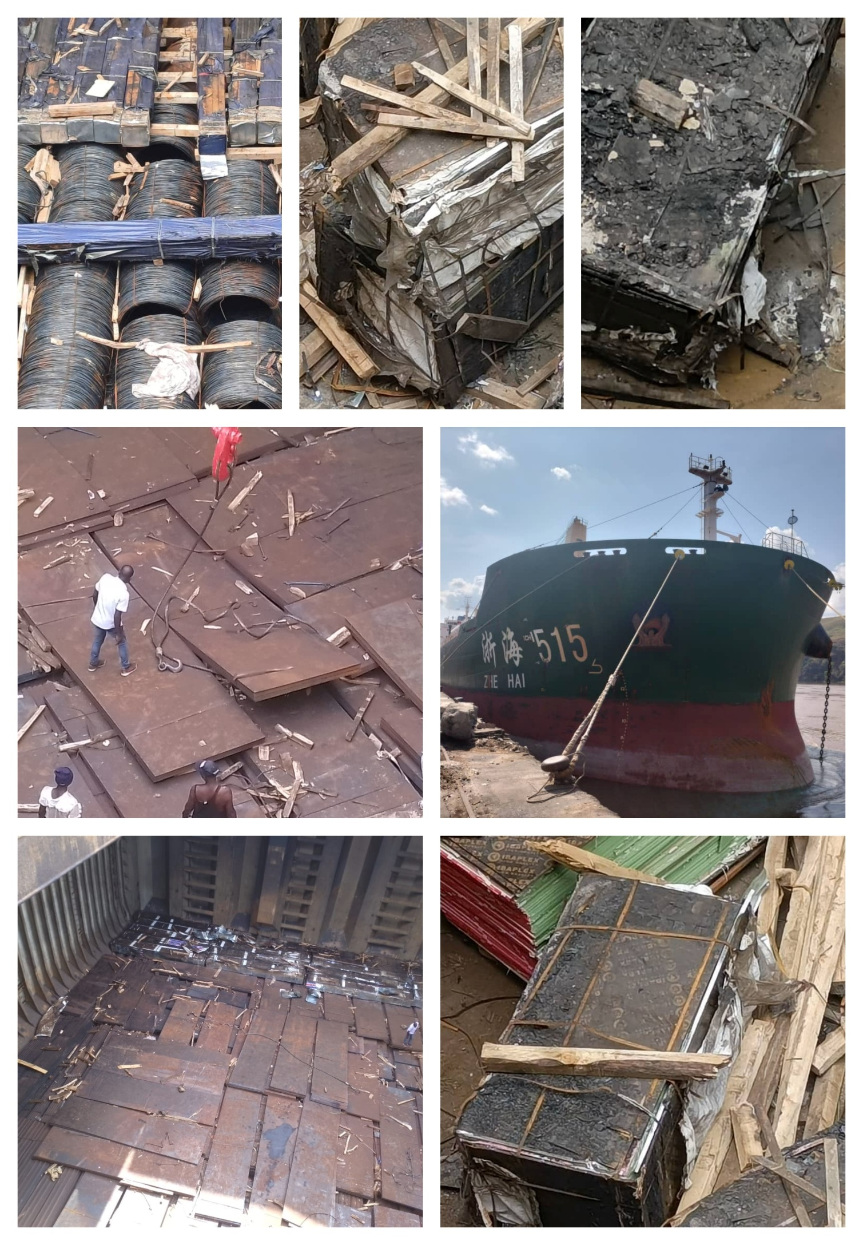
About ULA
United Loss Adjusters and Surveyors (ULA) is a leading international provider of Adjusters, Surveyors, Solicitors and Consultants, offering unrivalled technical and legal solutions with exclusive access to the London Market's leading specialists.
Established in 2002, ULA boasts strategic headquarters in both the Middle East and the United Kingdom. Today, it stands as the key strategic ally of Clyde & Co., operating across 60+ countries, and serves as the correspondent and associate for numerous global technical service providers present in over 140 countries. ULA clientele includes esteemed entities such as insurers, reinsurers, brokers, P&I clubs, ship owners, shipyards, H&M insurers, agencies, and various other stakeholders.
Lines of business:
- Insurance & Re-insurance
- Claims solutions and loss adjusting across all major lines: aviation, cargo, marine, property, fine arts and special risks claims
- Cargo & Containers
- Marine & Offshore
- Global Claim Recoveries & Legal Support
Our team:
Our team comprises seasoned professionals proficient in Marine, Insurance, Finance, Engineering, and Law, renowned for their integrity and credibility. Backed by a dynamic, strategically located workforce, we swiftly address your queries with promptness and precision whenever and wherever our services are required. ULA maintains unwavering independence, ensuring unbiased perspectives uninfluenced by stakeholders, thereby earning your trust unequivocally.
ULA’s team members are recognised:
- Chartered Engineers
- Consultants
- Inspectors & Auditors
- Insurance & Re-Insurance Underwriters
- Loss & Average Adjusters
- Master Mariners & Chief Engineers
- Naval Architects, Marine & Offshore Engineers
- Solicitors
- Sworn Surveyors
ULA’s team members are also recognised members of the following international institutions:
- The Association of Average Adjusters (AAA)
- The Bar Council of England and Wales
- The Chartered Insurance Institute (CII)
- The Chartered Institute of Loss Adjusters (CILA)
- The European Federation of Loss Adjusting Experts (FUEDI)
- The Institute of Fire Engineers (IFE)
- The Institute of Marine Engineering, Science and Technology (IMarEST)
- The UK Engineering Council
- The Royal Institute of Naval Architects (RINA)
- The International Institute of Marine Surveying (IIMS)
- The Royal Institute of Chartered Surveyors (RICS)

Contact person
Annie Abdel Massih
Claims Director
United Kingdom: 71-75 Shelton Street, Covent Garden | London, England - WC2H 9JQ

Registered name United Loss Adjusters and Surveyors Ltd.

24/7 Contacts & Claims support – T: +44 (0) 20 3287 3326 | M/WhatsApp: +44 (0) 7 375 110 573
Office E: claims@unitedlossadjusters.com
W: https://www.unitedlossadjusters.com/



